18027

Practical No. 1
Study of Networking

Aim :- To study the IP address.

Circuit Diagram :-

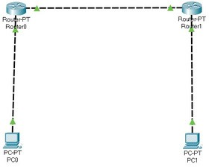

Program :-
Router 0 > cli :- enable configure terminal interface fastethernet 0/0 ip address 10.0.0.1 255.0.0.0 no shutdown exit interface fastethernet 0/1 ip address 20.0.0.1 255.0.0.0 no shutdown
exit

Router 1 > cli :- enable configure terminal interface fastethernet 0/0 ip address 40.0.0.1 255.0.0.0 no shutdown exit
interface fastethernet 0/1 ip address 20.0.0.2 255.0.0.0 no shutdown exit

Pc 0 > Desktop > Ip configuration :- ipv4 : 10.0.0.2 subnet mask : 255.0.0.0 Default gateway: 10.0.0.1

Pc 1 > Desktop > Ip configuration :- ipv4 : 40.0.0.2
subnet mask : 255.0.0.0 Default gateway: 40.0.0.1

Output :-
PC0 :-

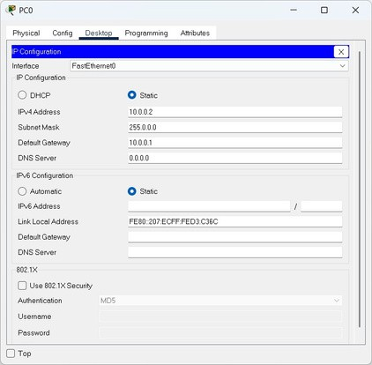

PC1:-

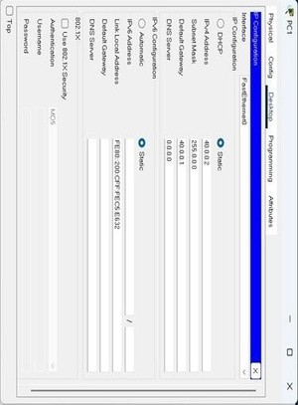

Conclusion :- The program was executed successfully

Practical No. 2

Study of Network Layer

Static Routing

Aim :- To study Static routing.

Circuit Diagram :-

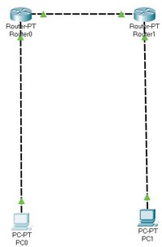

Program :-
Router 0 > cli :- enable configure terminal interface fastethernet 0/0 ip address 10.0.0.1 255.0.0.0 no shutdown
exit interface fastethernet 0/1 ip address 20.0.0.1 255.0.0.0 no shutdown exit ip route 40.0.0.0 255.0.0.0 20.0.0.2

Router 1 > cli :- enable configure terminal interface fastethernet 0/0 ip address 40.0.0.1 255.0.0.0 no shutdown
exit
interface fastethernet 0/1 ip address 20.0.0.2 255.0.0.0 no shutdown exit ip route 10.0.0.0 255.0.0.0 20.0.0.1

Pc 0 > Desktop > Ip configuration :-
ipv4 : 10.0.0.2
subnet mask : 255.0.0.0 Default gateway: 10.0.0.1

Pc 1 > Desktop > Ip configuration :-
ipv4 : 40.0.0.2
subnet mask : 255.0.0.0

Default gateway: 40.0.0.1

Output :-
PC0 :-

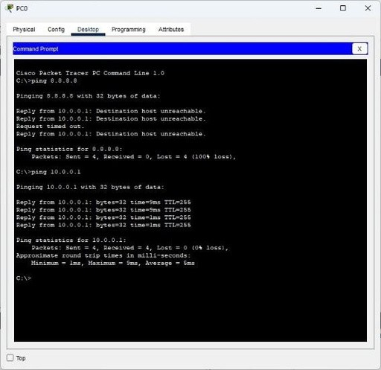

PC1 :-

Conclusion :- The program was executed successfully.

RIP Routing

Aim :- To study RIP routing.

Circuit Diagram :-

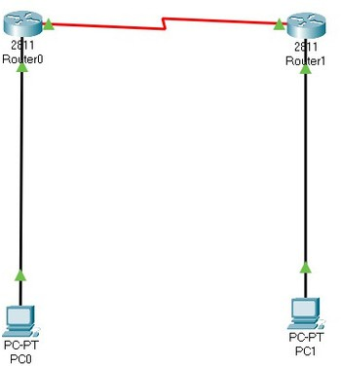

Program :-
Router 0 > cli :- enable configure terminal interface fastethernet 0/0 ip address 10.0.0.1 255.0.0.0 no shutdown
exit interface fastethernet 0/1 ip address 20.0.0.1 255.0.0.0 no shutdown exit router rip version 2 network 10.0.0.0 network 20.0.0.0 exit

Router 1 > cli :- enable configure terminal interface fastethernet 0/0 ip address 40.0.0.1 255.0.0.0 no shutdown
exit interface fastethernet 0/1 ip address 20.0.0.2 255.0.0.0 no shutdown exit router rip version 2 network 40.0.0.0 network 20.0.0.0 exit

Pc 0 > Desktop > Ip configuration :- ipv4 : 10.0.0.2 subnet mask : 255.0.0.0 Default gateway: 10.0.0.1

Pc 1 > Desktop > Ip configuration :- ipv4 : 40.0.0.2 subnet mask : 255.0.0.0
Default gateway: 40.0.0.1

Output :-

PC0:-

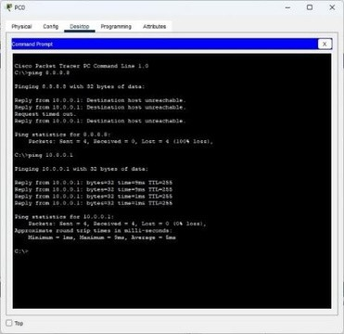

Conclusion :- The program was executed successfully.

OSPF Routing

Aim :- To study OSPF routing.

Circuit Diagram :-

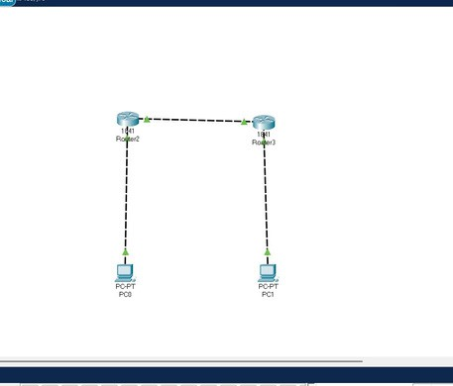

Program :-
Router 0 > cli :- enable configure terminal interface fastethernet 0/0 ip address 10.0.0.1 255.0.0.0 no shutdown
exit interface fastethernet 0/1 ip address 20.0.0.1 255.0.0.0 no shutdown
exit router ospf 1 network 10.0.0.0 0.255.255.255 area 0 network 20.0.0.0 0.255.255.255 area 0 exit

Router 1 > cli :- enable configure terminal interface fastethernet 0/0 ip address 40.0.0.1 255.0.0.0 no shutdown
exit interface fastethernet 0/1 ip address 20.0.0.2 255.0.0.0 no shutdown
exit router ospf 2 network 40.0.0.0 0.255.255.255 area 0 network 20.0.0.0 0.255.255.255 area 0 exit

Pc 0 > Desktop > Ip configuration :- ipv4 : 10.0.0.2 subnet mask : 255.0.0.0
Default gateway: 10.0.0.1

Pc 1 > Desktop > Ip configuration :- ipv4 : 40.0.0.2 subnet mask : 255.0.0.0

Default gateway: 40.0.0.1

Output :-

PC0:-

PC1:-

Conclusion :- The program was executed successfully.

Practical No. 3
Study of Application Layer

DHCP
Aim :- To study DHCP.

Program :-
Router 0 > cli :- enable configure terminal interface fastethernet 0/0 ip address 10.0.0.1 255.0.0.0 no shutdown
exit ip dhcp pool syit network 10.0.0.0 255.0.0.0 default-router 10.0.0.1 ip dhcp excluded-address 10.0.0.2
10.0.0.1 ip dhcp pool syit network 10.0.0.0 255.0.0.0 default-router 10.0.0.1 ip dhcp excluded-address 10.0.0.2
10.0.0.13
exit
Output:-

Pc1

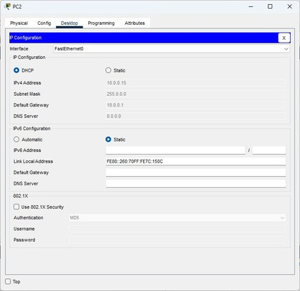

Conclusion :- The program was executed successfully.

DNS

Aim :- To study DNS.

Circuit Diagram :-

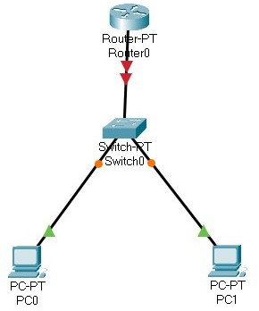

Program :-
Router 0 > cli :- enable configure terminal interface fastethernet 0/0 ip address 10.0.0.1 255.0.0.0 no shutdown
exit ip dhcp pool syit network 10.0.0.0 255.0.0.0 default-router 10.0.0.1 dns-server 8.8.8.8 exit ip host www.syit.com 10.0.0.1 exit

Pc 0 > Desktop > Ip configuration :- ipv4 : 10.0.0.2 subnet mask : 255.0.0.0
Default gateway: 10.0.0.1

Pc 1 > Desktop > Ip configuration :- ipv4 : 10.0.0.3 subnet mask : 255.0.0.0
Default gateway: 10.0.0.1

Output:-

Conclusion:-The program executed Successfully

FTP

Aim :- To study FTP.

Diagram:

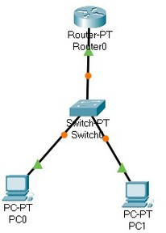

Program :-
Router 0 > cli :- enable configure terminal interface fastethernet 0/0 ip address 10.0.0.1 255.0.0.0 no shutdown
exit ip ftp username bscit ip ftp password syit ip ftp server enable exit

Pc 0 > Desktop > Ip configuration :- ipv4 : 10.0.0.2 subnet mask : 255.0.0.0 Default gateway: 10.0.0.1

Pc 1 > Desktop > Ip configuration :- ipv4 : 10.0.0.3 subnet mask : 255.0.0.0
Default gateway: 10.0.0.1

Pc 0 > Desktop > Text Editor :-
This is from PC0

Pc 0 > Desktop > Command Prompt :-
ftp 10.0.0.1 username : bscit password : syit put testfile.txt

Pc 1 > Desktop > Command Prompt :-
ftp 10.0.0.1
username : bscit password : syit get testfile.txt Output:-

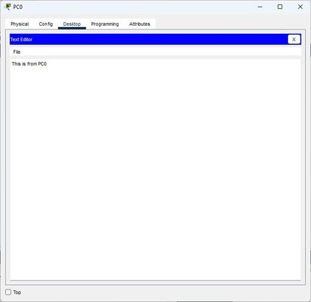

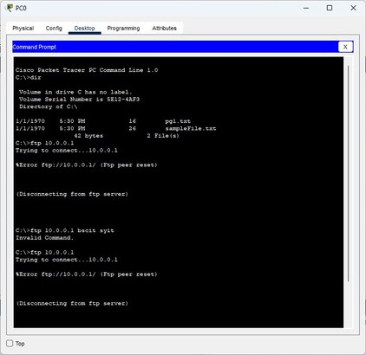

Conclusion:-The program executed Successfully

HTTP

Aim :- To study HTTP.

Circuit Diagram:-

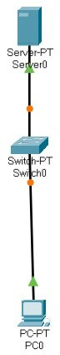

Program :- Server 0 > Desktop > Ip configuration :- ipv4 : 10.0.0.2 subnet mask : 255.0.0.0 Default gateway: 0.0.0.0

Server 0 > Services > HTTP :-
HTTP : on HTTPS : on

Server 0 > Services > TFTP :- service: off

Server 0 > Services > HTTP > index.html > Edit :-
<html>
<head>
<title>SYIT</title>
</head>
<body>
<h1>I am SYIT</h1>
</body>
</html>

Pc 0 > Desktop > Ip Configuration :- ipv4 : 10.0.0.3 subnet mask : 255.0.0.0 Default gateway: 10.0.0.2

Conclusion:-The program executed Successfully.

TELNET

Aim :- To study TELNET.
Circuit diagram:-

Program :-
Router 0 > cli :- enable configure terminal interface fastethernet 0/0 ip address 10.0.0.1 255.0.0.0 no shutdown
exit line vty 0 10 password syit login transport input telnet exit exit

Pc 0 > Desktop > Ip configuration :- ipv4 : 10.0.0.2 subnet mask : 255.0.0.0 Default gateway: 10.0.0.1

Pc 1 > Desktop > Ip configuration :- ipv4 : 10.0.0.3 subnet mask : 255.0.0.0

Default gateway: 10.0.0.1

Output:-

Conclusion:-The program executed Successfully.

Aron Maryapnor S.I.W.S. College Major Practical
MAJOR I PRACTICAL (Python)
PRACTICAL NO:-1
STUDY OF CRYPTOGRAPHY
Aim:-To study cryptography substitution technique
Program:-
import string

def ceaser_cipher(input_str):
ENCRYPT_SHIFT = 3
DECRYPT_SHIFT = -3
cipher_str = ""
plain_str = ""
for char in input_str:
if char in string.ascii_lowercase:
i = string.ascii_lowercase.index(char)
new_i = (i + ENCRYPT_SHIFT) % 26
cipher_str += string.ascii_lowercase[new_i]
elif char in string.ascii_uppercase:
i = string.ascii_uppercase.index(char)
new_i = (i + ENCRYPT_SHIFT) % 26
cipher_str += string.ascii_uppercase[new_i]
else:
cipher_str += char

print(f"Encrypted (Cipher Text) :\t{cipher_str}")
for char in cipher_str:
if char in string.ascii_lowercase:
i = string.ascii_lowercase.index(char)
new_i = (i + DECRYPT_SHIFT + 26) % 26
plain_str += string.ascii_lowercase[new_i]
elif char in string.ascii_uppercase:
i = string.ascii_uppercase.index(char)
new_i = (i + DECRYPT_SHIFT + 26) % 26
plain_str += string.ascii_uppercase[new_i]
else:
plain_str += char
print(f"Decrypted (Plain Text) :\t{plain_str}")

print("Enter a String :", end="\t")
user_input = input()
ceaser_cipher(user_input)

Output:-
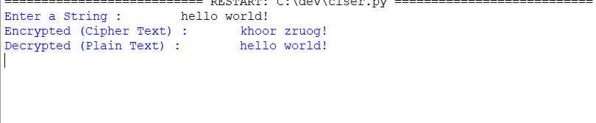

Conclusion :-The above program is successfully executed
PRACTICAL NO:-2
STUDY OF SYMMETRIC KEY - DES & AES
2)a)Aim:-To write python code for DES
Program:-
import pyDes
key = b"mysecret"
data_to_encrypt = b"Hello from DES!"
cipher = pyDes.des(key, padmode = pyDes.PAD_PKCS5)
encrypted_data = cipher.encrypt(data_to_encrypt)
print (f"Original Data: {data_to_encrypt.decode()}")
print (f"Encrypted Data Looks like this: {encrypted_data}")
decrypted_data = cipher.decrypt(encrypted_data)
print (f"Decrypted Data: {decrypted_data.decode()}")

Output:
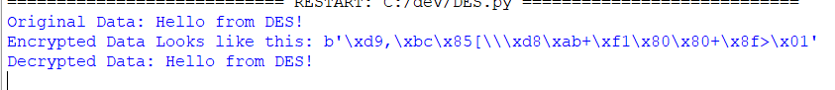
Conclusion :-The above program is successfully executed

2)b)Aim:-To write a code in python for AES
Program:-
from Crypto.Cipher import AES
from Crypto.Util.Padding import pad, unpad
key = b'my_secret_key_16' # exactly 16 bytes
data_to_encrypt = b'Hello from modern AES!'
cipher = AES.new(key, AES.MODE_CBC)
iv = cipher.iv

encrypted_data = cipher.encrypt(pad(data_to_encrypt, AES.block_size))

print (f"Original Data: {data_to_encrypt.decode()}")
print (f"Encrypted Data looks like this: {encrypted_data}")
decrypt_cipher = AES.new(key, AES.MODE_CBC, iv)
decrypted_data=unpad(decrypt_cipher.decrypt(encrypted_data), AES.block_size)
print (f"Decrypted Data: {decrypted_data.decode()}")

Output: 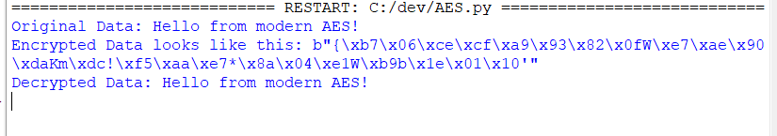

Conclusion :-The above program is successfully executed

PRACTICAL NO 3
STUDY OF ASYMETRIC KEY (DH & RSA)
3)a)Aim:-To write a python code for DH
Program:-
from cryptography.hazmat.primitives.asymmetric import dh
from cryptography.hazmat.primitives import serialization
from cryptography.hazmat.backends import default_backend
parameters = dh.generate_parameters(generator=2, key_size=512, backend=default_backend())
alice_private_key = parameters.generate_private_key()
alice_public_key = alice_private_key.public_key()
bob_private_key = parameters.generate_private_key()
bob_public_key = bob_private_key.public_key()
alice_shared_key = alice_private_key.exchange(bob_public_key)
bob_shared_key = bob_private_key.exchange(alice_public_key)
print(f"Alice's Shared Secret: {alice_shared_key}")
print(f"Bob's Shared Secret: {bob_shared_key}")
if alice_shared_key == bob_shared_key:
print("\nSuccess! Shared keys match.")
else:
print("\nError! Shared keys do not match.")
Output:
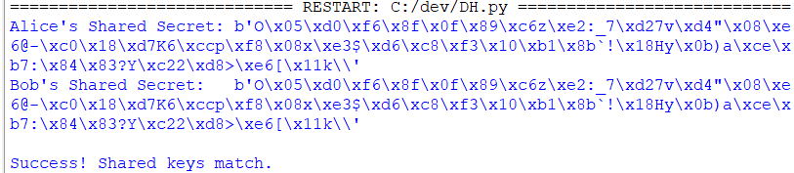

Conclusion :-The above program is successfully executed

3)b)Aim:-To write a code in python code for RSA
Program:-
from Crypto.PublicKey import RSA
from Crypto.Cipher import PKCS1_OAEP
key = RSA.generate(2048)
private_key = key
public_key = key.public_key()
data_to_encrypt = b'This is a top secret RSA message'
print (f"Original Data: {data_to_encrypt.decode()}")
cipher_rsa = PKCS1_OAEP.new(public_key)
encrypted_data = cipher_rsa.encrypt(data_to_encrypt)
print (f"Encrypted Data looks like this: {encrypted_data}")
decrypt_rsa = PKCS1_OAEP.new(private_key)
decrypted_data = decrypt_rsa.decrypt(encrypted_data)
print (f"Decrypted Data: {decrypted_data.decode()}")
assert data_to_encrypt == decrypted_data
print("Success! The message was encrypted and decrypted correctly.")

Output:
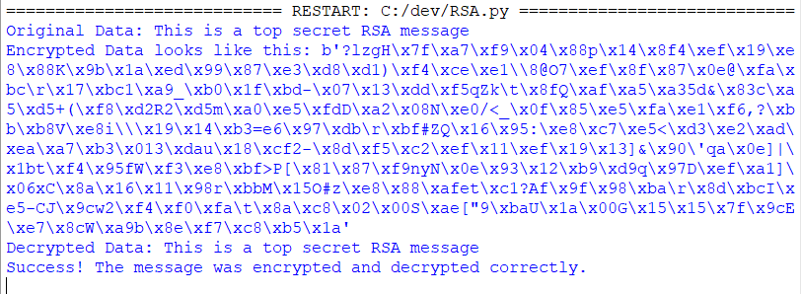
Conclusion :-The above program is successfully executed

PRACTICAL NO 4
STUDY OF MD5 ALGORITHM
Aim:- To write code in python in MD5
Program:-
import hashlib
data = "Hello, this is a test string"
md5_hash_object = hashlib.md5(data.encode())
hex_digest = md5_hash_object.hexdigest()
print (f"Original String : {data}")
print (f"MD5 Hash: {hex_digest}")

Output:-
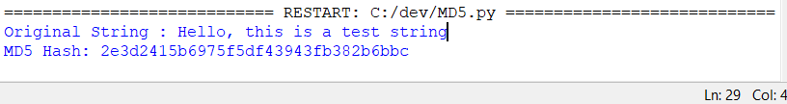
Conclusion :-The above program is successfully executed
PRACTICAL NO 5
STUDY OF HASH FUNCTION
Aim:-To write code in python for hash fuction
Program:-
def RSHash (data_string):
a = 378551
b = 63689
hash_value = 0
for char in data_string:
hash_value = hash_value * a + ord(char)
a = a * b
return hash_value
data = "hello world"
hash_result = RSHash(data)
print (f"Original String: {data}")
print (f"RS Hash Value: {hash_result}")
data2 = "world hello"
hash_result2 = RSHash(data2)
print (f"\nOriginal String: {data2}")
print (f"RS Hash Value: {hash_result2}")
Output:
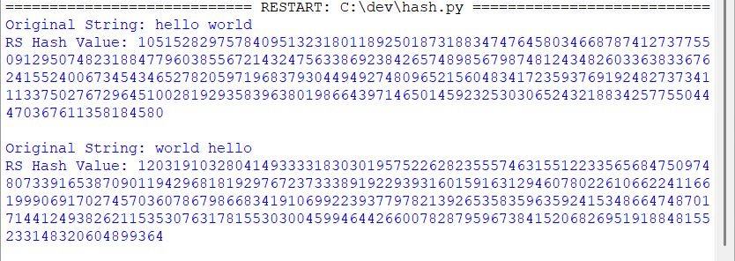
Conclusion :- The above program is successfully executed

